**MySQL Test**

**Instructions:**

* This test consists of a total of 10 questions.
* Each question carries 10 marks, resulting in a total of 100 marks.
* Write the SQL queries to answer each question.
* Feel free to use any necessary syntax, functions, or clauses supported by MySQL.
* The queries should be optimized and accurate.
* Write your answers below to each question.
* Good luck!

**Questions**:

1. **Create a table named "Employees" with the following columns:**

* emp_id (integer, primary key)
* emp_name (varchar, maximum length of 50)
* department (varchar, maximum length of 30)
* salary (decimal with precision 10, scale 2)

CREATING THE “Employees” TABLE:

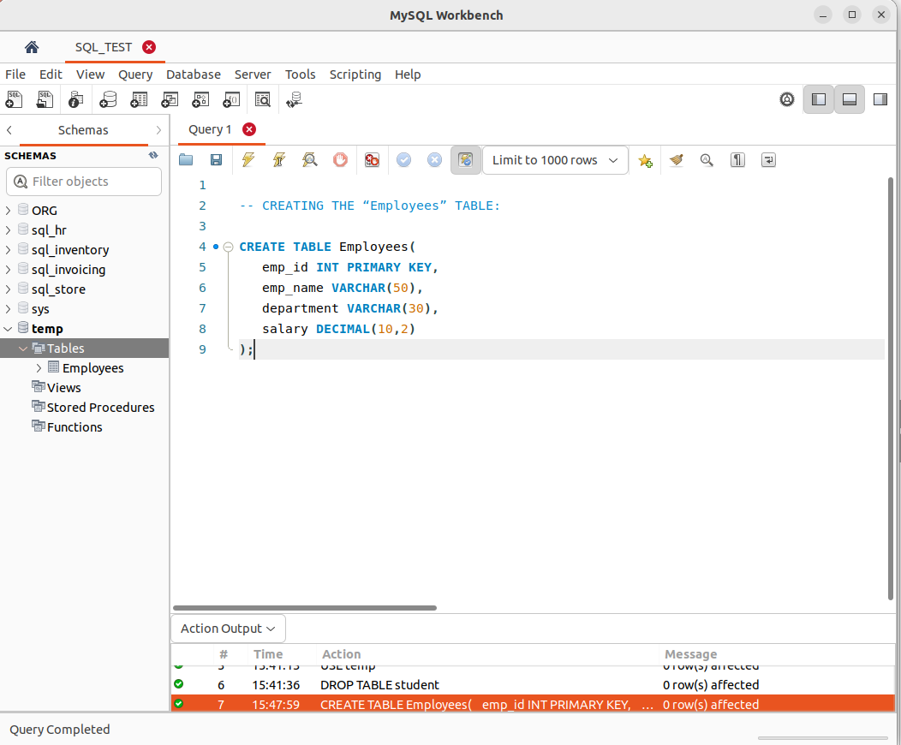

**2. Insert the following data into the "Employees" table:**

* emp_id: 1, emp_name: "John Doe", department: "HR", salary: 50000.00
* emp_id: 2, emp_name: "Jane Smith", department: "Finance", salary: 60000.00
* emp_id: 3, emp_name: "Michael Johnson", department: "IT", salary: 55000.50

INSERTING DATA INTO EMPLOYEES TABLE :

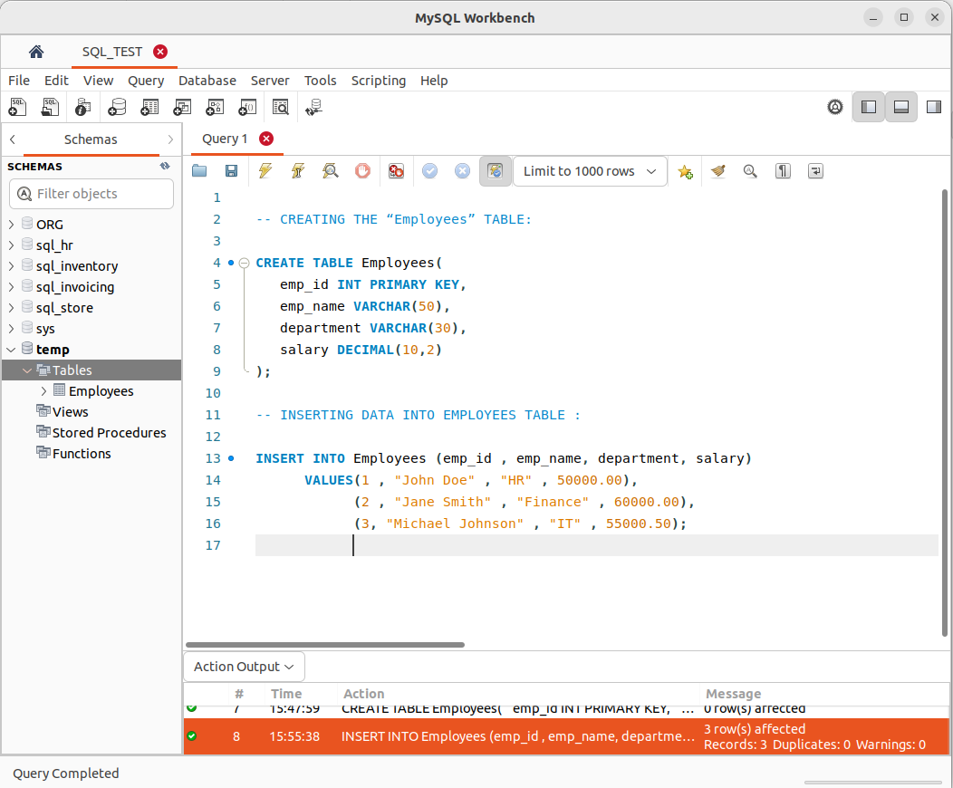.

verifying that values are inserted into the table “Employees”:

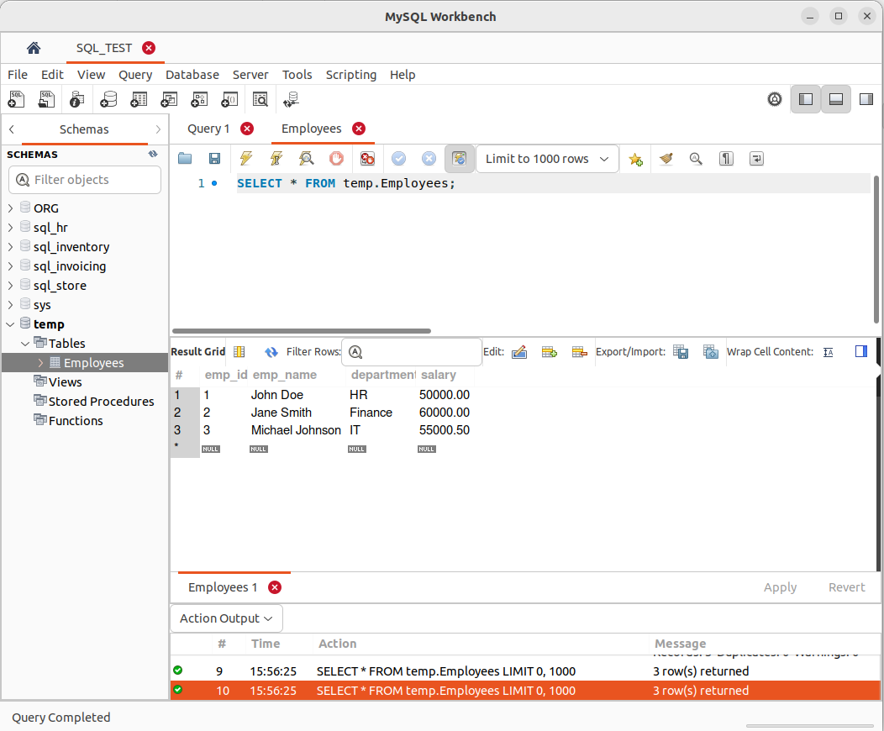

**3.Write a query to retrieve the names of all employees in the "HR" department.**

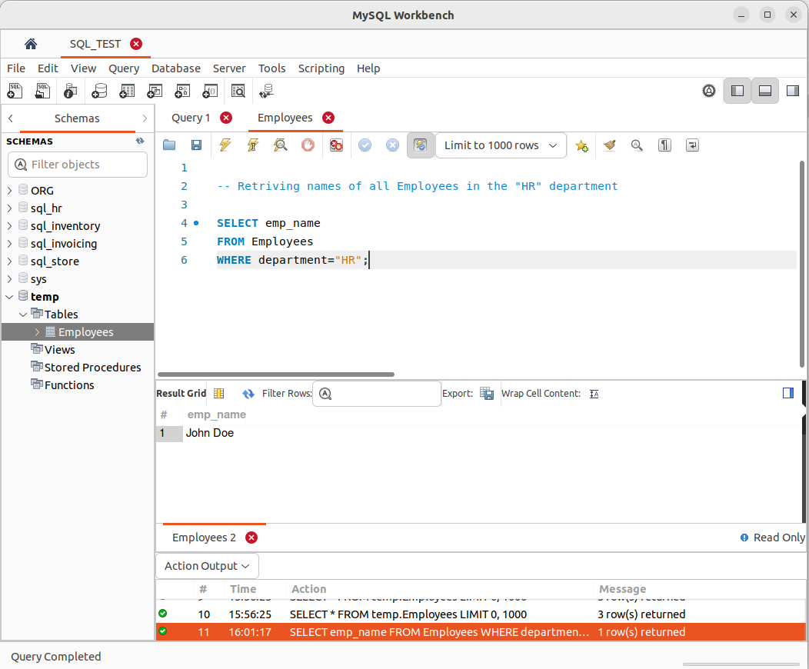

**4.Calculate the average salary of all employees.**

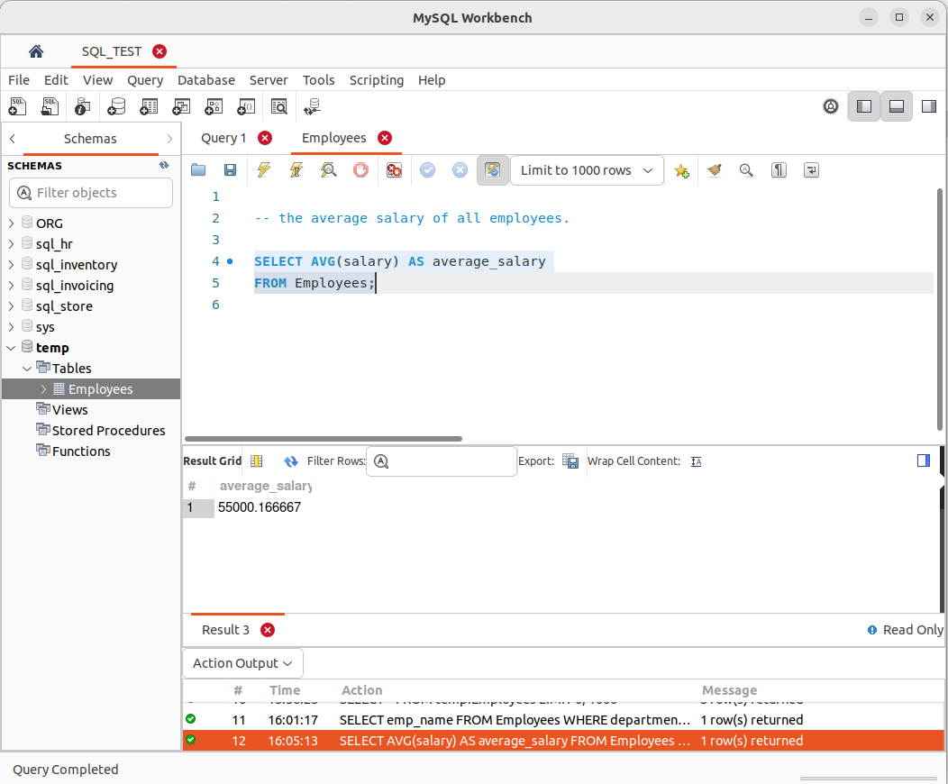

**5.Update Jane Smith's salary to 65000.00.**

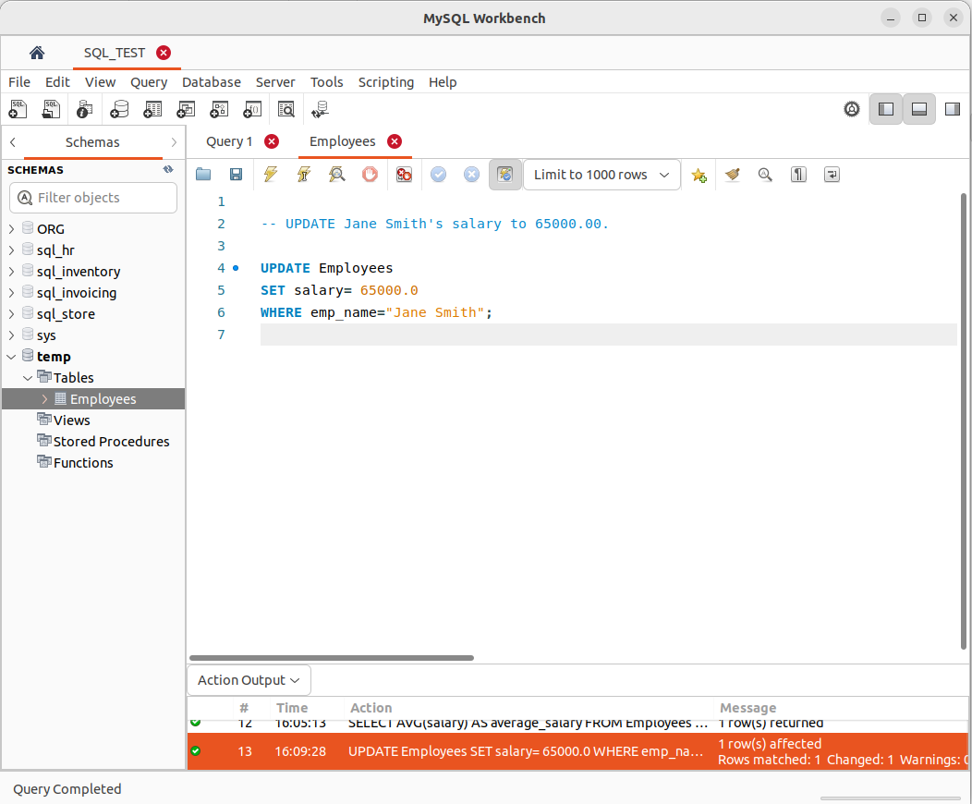**.**

verifying that Jane Smith salary is updated to 65000.00 :

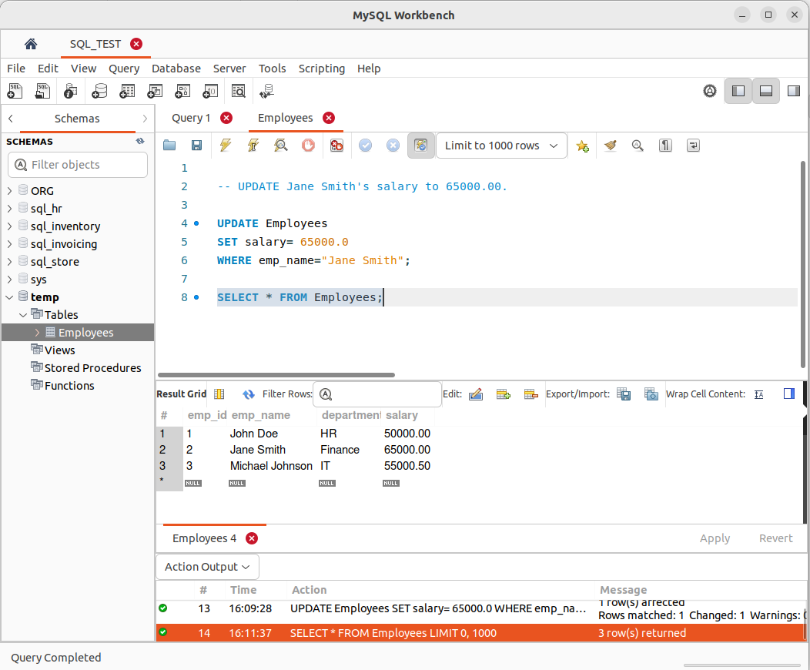

**6.Delete the employee with emp_id = 3 from the table.**

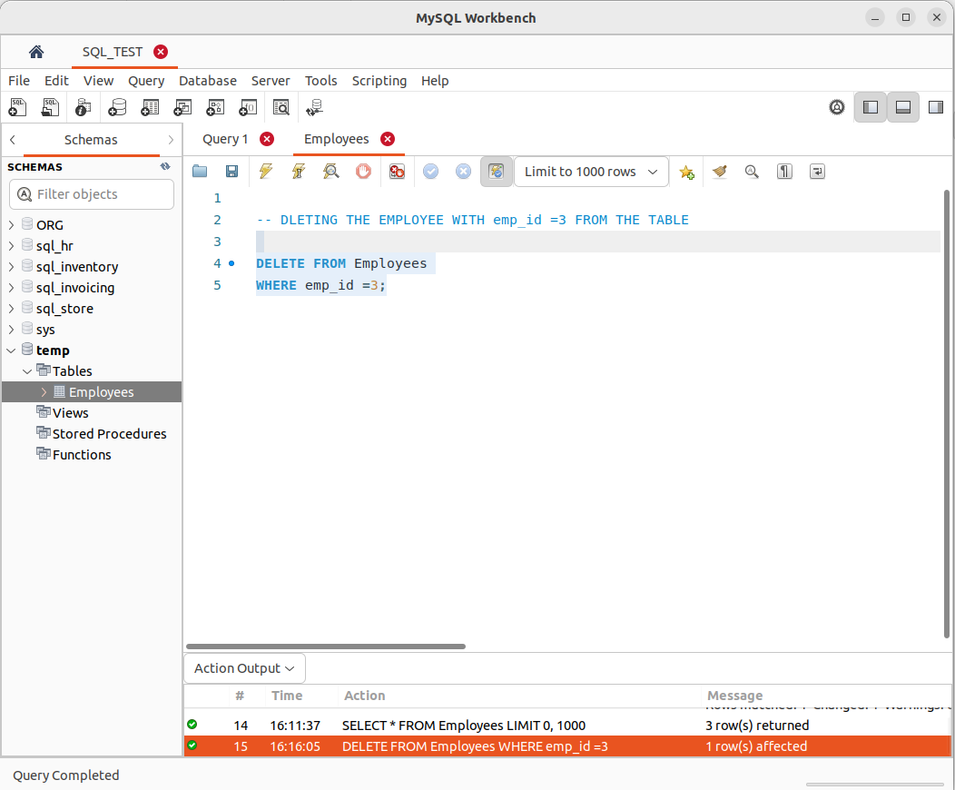**.**

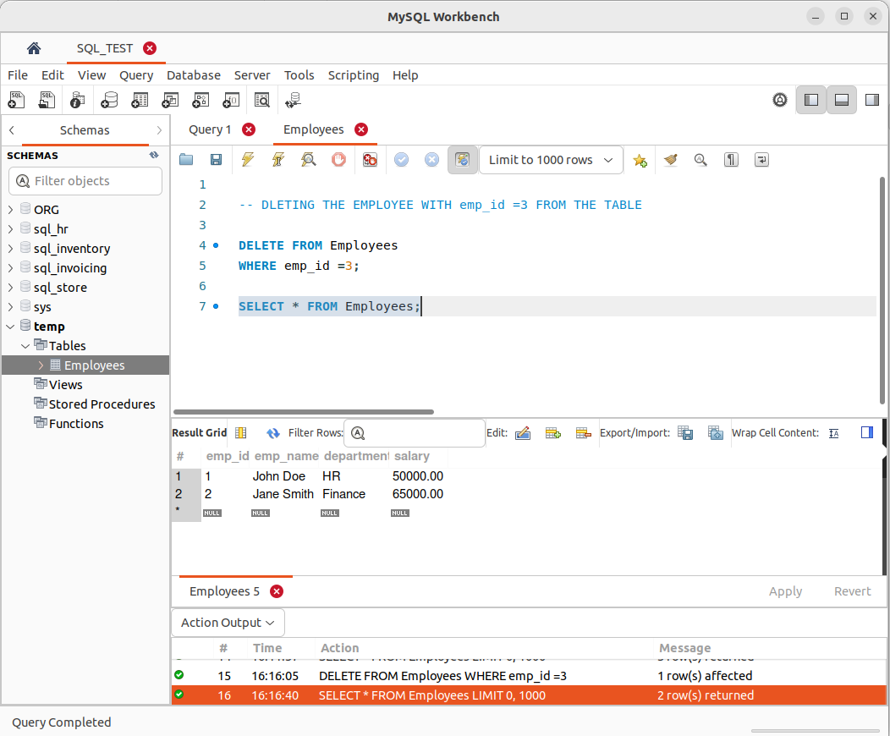

**7.Write a query to find the highest salary among all employees.**

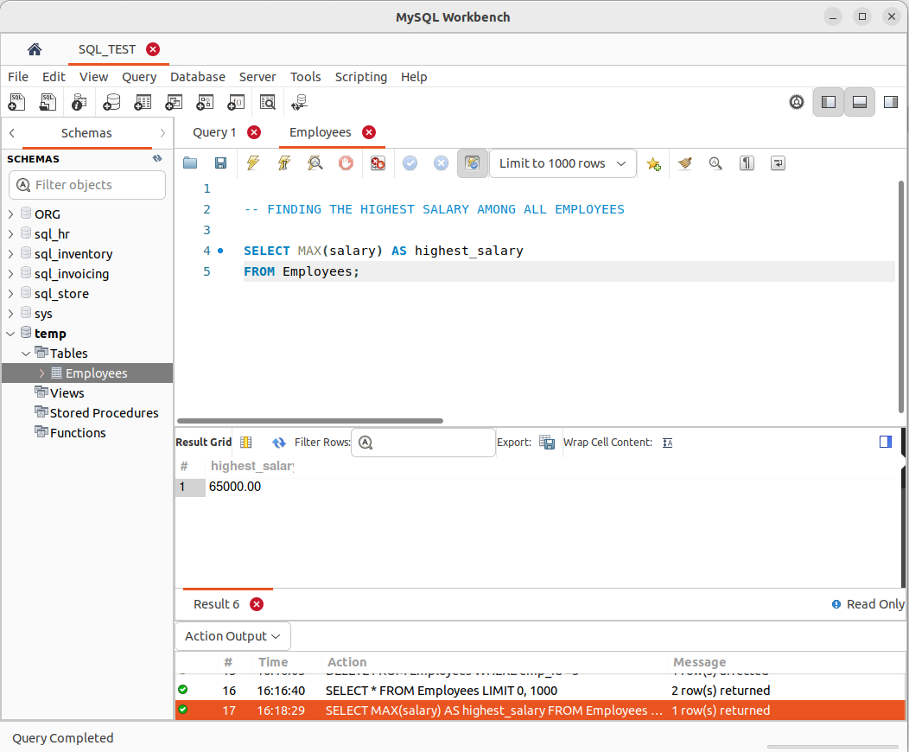

**8. Create a new table named "Projects" with the following columns:**

* project_id (integer, primary key)
* project_name (varchar, maximum length of 100)
* start_date (date)
* end_date (date)

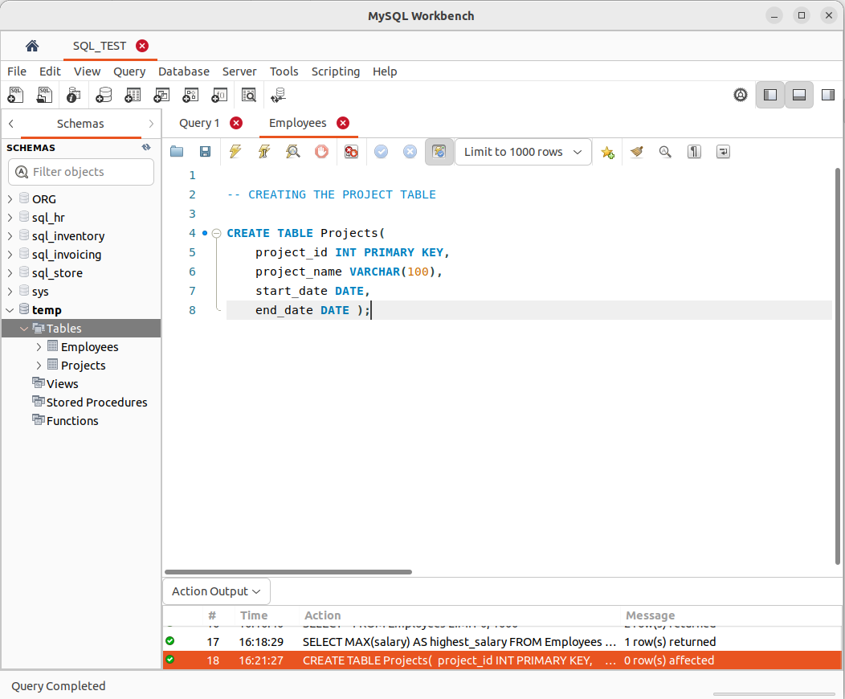

**9. Insert the following data into the "Projects" table:**

* project_id: 1, project_name: "Website Redesign", start_date: '2023-06-01', end_date: '2023-09-30'
* project_id: 2, project_name: "Database Migration", start_date: '2023-07-15', end_date: '2023-10-31'

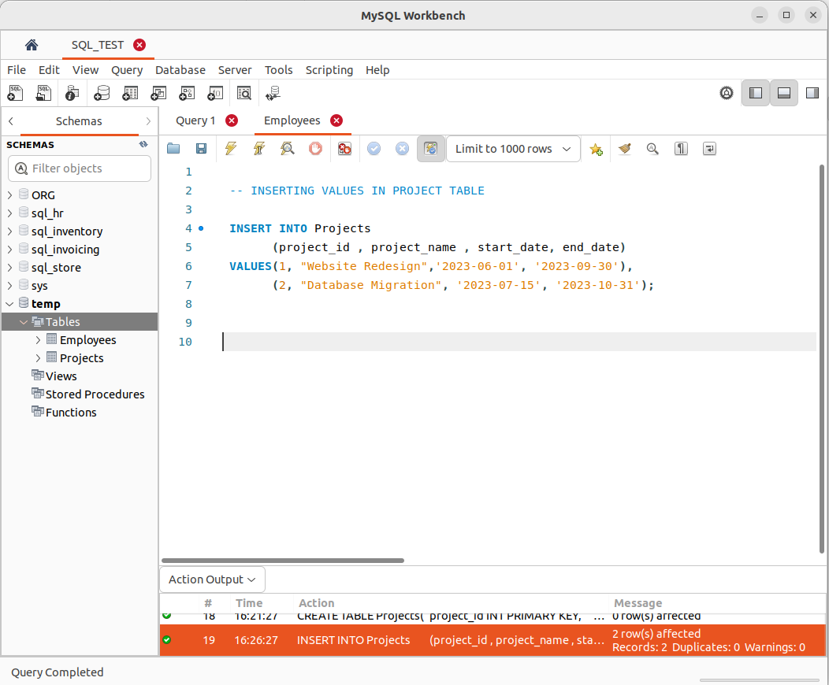

.

verifying that values are inserted into project table :

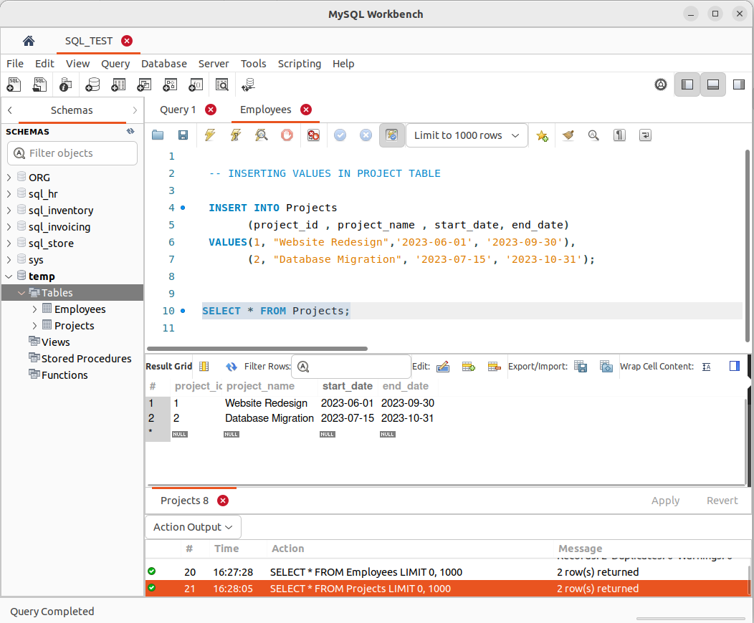.

**10. Write a query to find all employees and their corresponding project names (if any). Display all employees, even if they are not assigned to any project.**